Bishop Kelley Athletic Department “Spirit Wear” Order
Please note that some items will need to be ordered and can take several weeks to be completed

Name: _______________________________________ Phone: ____________________________________
Please mark if you would like order sent home with student: Yes______________ No ____________________

Please circle the design: (All Designs are Embroidered)
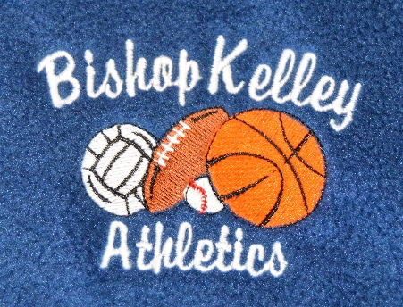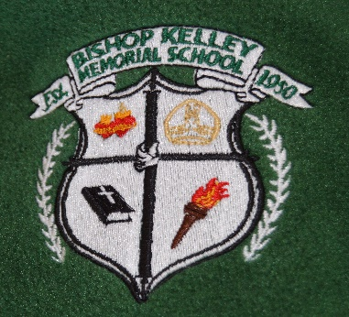

Please Circle the Color:
Navy Blue (Jr High Only) Forest Green Gray (Not a school uniform)
Please circle a style:
Polar Fleece with a full zipper Polar Fleece with ¼ zip** Hooded Sweatshirt (Not a school Uniform)
Dry-Fit Jacket with ¼ zip (Available in Navy and Forest Green and only Adult sizes)** See below for cost
Please circle a size:
Youth Small Youth Medium Youth Large
Adult X Small Adult Small Adult Medium Adult Large
Adult X Large Adult XX Large Other_________________
Cost:
Youth thru Adult X Large Polar Fleece $36*
Youth thru Adult X Large Sweatshirt $ 30*
Adult X Small thru Adult X Large Dry- Fit Jacket $ 46*
- *Please add an additional $ 3 for every X over XL

** Polar Fleece with ¼ zip is no longer available in youth sizes

Please Circle a Design: (All Designs are Silk Screen)
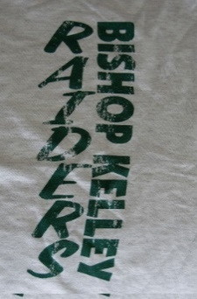
The words MOM or DAD or GRANDPARENT can be added to the Bishop Kelley Catholic School design at an additional cost. Please contact me if you would like this done. afrancis@bishopkelleylapeer.org
Please circle the Color:
Forest Green Gray
Please Circle a Style:
T-Shirt Long Sleeve T-Shirt Hooded Sweatshirt Crew Neck Sweatshirt
Please circle a size:
Youth Small Youth Medium Youth Large Youth X Large
Adult Small Adult Medium Adult Large Adult X Large Adult XX Large Other_________________
Cost:
Youth thru Adult X Large T-Shirt $ 12*
Youth thru Adult X Large Long Sleeved T-Shirt $ 16*
Youth thru Adult X Large Hooded Sweatshirt $ 30 *
Youth thru Adult X Large Crew Neck Sweatshirt $ 25*
- *Please add an additional $ 3 for every X over XL
Miscellaneous Items:
Bishop Kelley Catholic School Window Clings $ 6 NEW DESIGN
Bishop Kelley Raider Knit Cap $ 10
Bishop Kelley Raiders Auto Mug $ 10
Bishop Kelley Canvas Tote Bag (while supplies last) $ 3
Bishop Kelley Lanyards (while supplies last) $ 6
Order Total:
Item 1: ________ + Item 2:____________+ Item 3:___________
Total__________________
MI Sales tax (x.06)_________________
Grand Total ======================

